Classroom Diagnostic Tools Reminders
Online Tools Training Software Download
Go to: https://pa.drcedirect.com/default.aspx and select the “Online Tools Training Software Download-Windows” if you would like a review of the tools available to the students during testing.
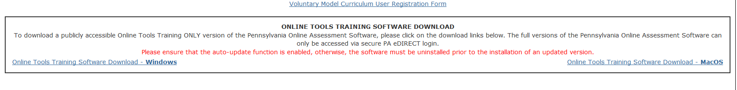

See page 7 of the Classroom Diagnostic Tools User Guide V4.0 for further instructions.
Printing Student Login Tickets
For directions to view/print test session tickets, refer to page 41 of the Classroom Diagnostic Tools User Guide V4.0 for instructions.
How to Reset Student Test Logins
For directions to reset student test logins, refer to page 42 of the Classroom Diagnostic Tools User Guide V4.0 for instructions.
For directions to unlock a test ticket, refer to page 49 of the Classroom Diagnostic Tools User Guide V4.0 for instructions.
*Remember, after 20 minutes of inactivity, the PA Online Assessment software will automatically exit the test. The student will then have to sign back in to the test to finish. If it is still the same day the student originally signed into the test, the software will only require the original student login for the student to regain access to the test. On a subsequent day, the student’s ticket will need to be reset/unlocked.
Adding a Student to Your Roster
In order to add a student to your roster, go to the "Test Sessions" tab and search for the student. Then hit the "Action" button and search for the student and print his or her ticket. Refer to page 27 of the Classroom Diagnostic Tools User Guide V4.0 for further instructions.

